Experimental Tutorial #1

Safety notes
  - No eating or drinking inside the laboratory.
  - Avoid touching heated or electrically active components.
  - Ensure hands are dry and avoid placing metal objects near powered circuits.
  - Do not modify wiring while the supply is ON.
  - Report damaged cables or unusual odors immediately.
  - Maintain a clean, organized workspace.

Introduction
This laboratory session investigates the operation of a series linear voltage regulator using a two-transistor closed-loop architecture, representative of a classical analog feedback system. Students will perform direct measurements on the completed circuit and analyze how negative feedback improves regulation performance.
In the second part of the tutorial, the Zener diode is characterized experimentally to understand its non-ideal behavior and dynamic resistance.

Learning objective
By the end of this tutorial, you will be able to:

Regulator Behavior
- Understand how negative feedback stabilizes output voltage.
- Measure line regulation 𝑆_{𝑉}𝑖 and load regulation (output resistance) 𝑆_{𝐼}𝐿 of a closed-loop linear regulator.
- Observe how the feedback loop reacts to disturbances.

Reference Diode Characterization
- Identify the Zener breakdown operating region.
- Measure the Zener voltage and current under different bias conditions.
- Extract the dynamic resistance 𝑟_{𝑍} and relate it to regulator performance.

Required equipment
- Digital multimeter (voltage, resistance)
- DC power supply (12–15 V range)
- Pre-assembled laboratory board with the two-transistor feedback regulator
- Zener diode ZPD5V1 and series resistor (for Part 2)
- Hook-up wires

Closed-Loop Two-Transistor Voltage Regulator

Circuit overview
The circuit under test is the series-parallel negative-feedback regulator made of:
- Q1 (BD139): series pass transistor
- Q2 (2N2222): error amplifier comparing feedback voltage vs. Zener reference
- Zener diode providing the reference voltage
- Feedback divider (R3– R4) sampling the output
- Input capacitors improving stability
In this circuit, the output voltage Vo is sampled by a voltage divider formed by R3 and R4, establishing a feedback factor 𝛽 = 𝑅4 . The output from the divider serves as the feedback
𝑅3+𝑅4
voltage which is "subtracted" from the control voltage (i.e., the VZ across the Zener diode) through transistor Q2. The collector voltage of Q2 thus provides the input voltage Vi to our unity-gain follower amplifier. Capacitor C1 is included to narrow the amplifier's bandwidth, enhancing stability.
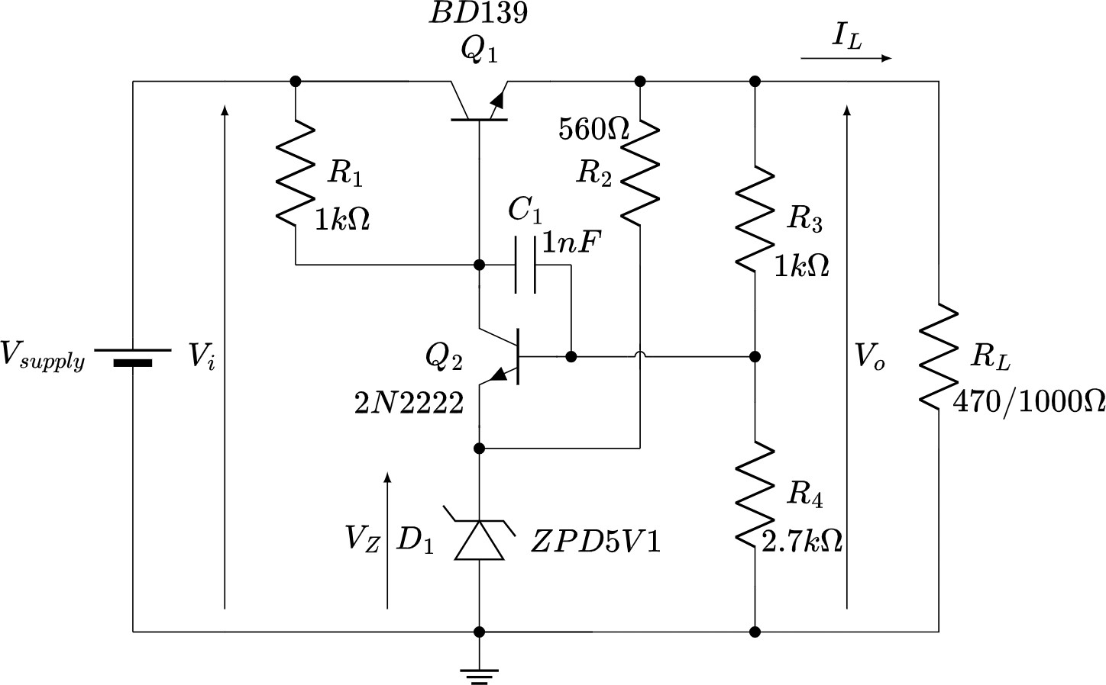

Fig. 1 – Voltage regulator circuit with negative feedback.

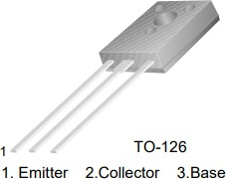
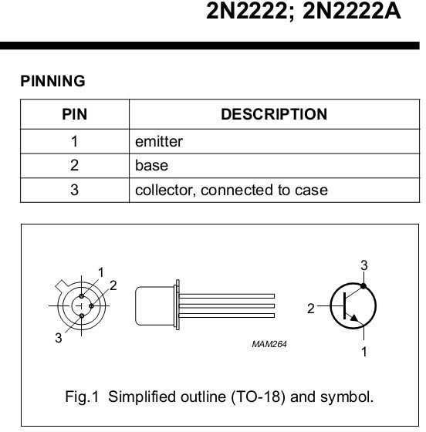
Fig. 2 – Pin configuration of the BD139 (left) and of 2N2222 (right) transistors.

Measurements

Objective:
Quantify how the output voltage changes when the input voltage varies.

Procedure:
- Set a fixed load resistor and measure its value through the multimeter.
- Apply 12 V at the input and measure: input voltage output voltage, Zener voltage (record all the displayed digits).
- Increase the input to 15 V and repeat the measurements.
- Change the resistor value and repeat from point 2.

Calculation:

- Evaluate the input voltage sensitivity as: 𝑆_{𝑉}𝑖
= Δ𝑉𝑜, expect a small value for the feedback
Δ𝑉𝑖

regulator.
- Compute the load current through the Ohm’s law.
- Evaluate the regulator output resistance (load current sensitivity) 𝑆_{𝐼}𝐿

= Δ𝑉𝑜
Δ𝐼𝐿


- Compute the efficiency 𝜂 = 𝑉𝑜
𝑉𝑖

Vi | RL | Vz | Vo | IL | 𝜂

𝑆 = Δ𝑉𝑜 = [V/V] with 𝑅 =

𝑉𝑖
Δ𝑉𝑖 𝐿

𝑆 = Δ𝑉𝑜 = [V/V] with 𝑅 =

𝑉𝑖
Δ𝑉𝑖 𝐿

𝑆 = Δ𝑉𝑜 = [Ω] with 𝑉 =

𝐼𝐿
Δ𝐼𝐿 𝑖

𝑆 = Δ𝑉𝑜 = [Ω] with 𝑉 =

𝐼𝐿
Δ𝐼𝐿 𝑖

Zener Diode Characterization

Circuit overview
The circuit to build is shown in Figure 3. It is a simple Zener diode biasing network, consisting of the variable panel power supply, a resistor, and the diode. Figure 4 shows the main characteristics of the Zener diode.
The goal of this phase of the exercise is to verify the breakdown condition of the Zener diode and to measure the voltage across the Zener and the current flowing through it as the power supply voltage varies from +12V to +15V. This allows us to determine the Zener's dynamic resistance under breakdown conditions.

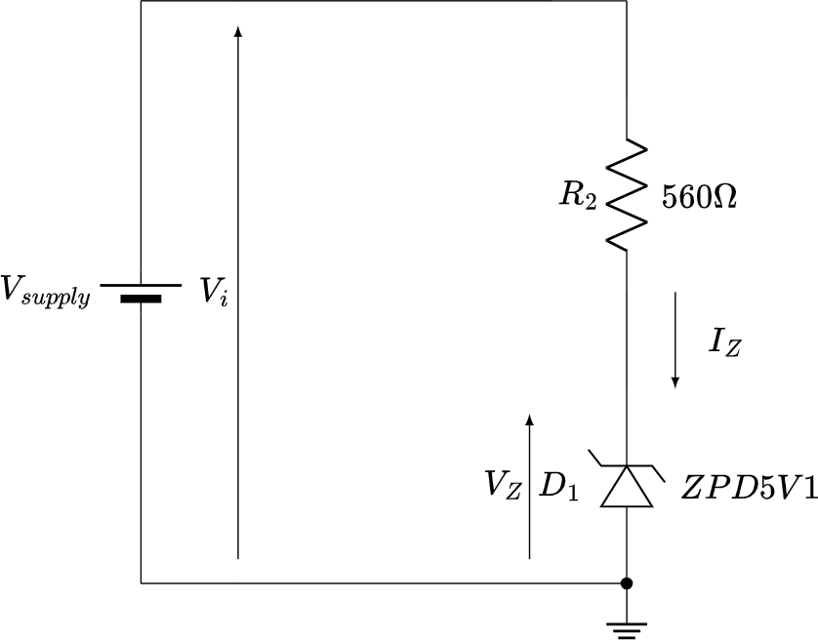

Fig. 3 – Circuit for the measurement of the Zener diode’s dynamic resistance.
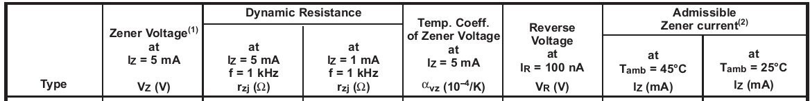

Fig. 4 – Zener diode’s characteristics (ZPD5V1).

Measurements

Objective:
Quantify the Zener’s dynamic resistance.

Procedure:
- Measure the value of 𝑅₁ the multimeter.
- Build the circuit as in Fig. 3.
- Apply 12 V at the input and measure: the input voltage and the Zener voltage (record all the displayed digits).
- Increase the input to 15 V and repeat the measurements.

Calculation:
- Evaluate the voltage across 𝑅₁ and calculate the current through the Ohm’s law.

- Evaluate the Zener dynamic resistance as 𝑟_{𝑍}
= Δ𝑉𝑍
Δ𝐼𝑍

Vi | R1 | Vz | IZ

𝑟_{𝑍}
= Δ𝑉𝑍 = [Ω]
Δ𝐼𝑍

